Accessibility Guide for Instructors (WCAG 2.1 A & AA Practical Guide)

Contents
Accessibility Guide for Instructors (WCAG 2.1 A & AA Practical Guide) 1
Images and Alt Text 4
WCAG Reference 4
What this means 4
What to do 4
Examples 6
What to avoid 6
How to do it 7
Charts and Graphs 9
WCAG Reference 9
What this means 9
What to do 9
What to avoid 9
Examples 10
How to do it 11
Headings and Structure 13
WCAG Reference 13
What this means 13
What to do 15
Examples 15
What to avoid 16
How to do it 17
Lists 19
WCAG Reference 19
What this means 19
What to do 19
Examples 19
What to avoid 20
How to do it 20
Links 22
WCAG Reference 22
What this means 22
What to do 22
Examples 23
What to avoid 23
How to do it 24
Color and Contrast 27
WCAG Reference 27
What this means 27
What to do 27
Non-text contrast 30
What to avoid 30
How to do it 31
Tables 32
WCAG Reference 32
What this means 32
What to do 32
What to avoid 32
Examples 32
Table captions (Canvas requirement) 34
How to do it – Set Caption 35
How to do it – Set Header Row 35
Video and Captions 36
WCAG Reference 36
What this means 36
What to do 36
What to avoid 36
How to do it 37

Images and Alt Text

WCAG Reference
- 1.1.1 (A) Non-text Content

What this means
Images need a short text description so screen readers can communicate their meaning. This description is called alt text.
Effective alt text identifies what the image is and why it matters in context.

What to do
- Add alt text to all meaningful images
- Include a brief anchor (what it is)
- Explain the purpose or concept (why it matters)
- Keep it concise and specific (~120 characters or less in Canvas)
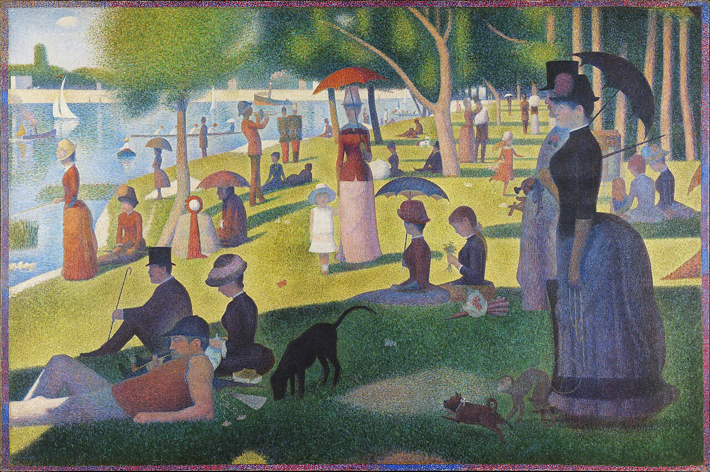

What is Good Alt Text
Effective alt text for WCAG 2.1 AA compliance is usually brief, focused, and purposeful. In Canvas, it’s recommended to keep alt text around 125 characters or less, since the Canvas Accessibility Checker flags longer descriptions even if other tools may not. Good alt text typically includes two things: the anchor, or what the image is actually showing, and the context, or why the image is being presented to the learner. Rather than describing every visual detail, the goal is to communicate the image’s instructional purpose without repeating surrounding text. This means even complex images often do not require long or highly detailed descriptions unless those details are essential to understanding the content.
Anchor
A brief anchor names the subject efficiently (e.g., “Seurat’s painting”).

Phrases like “image of” or “picture of” are unnecessary and often lead to descriptions that stop at naming the image without context.

Context
The same image can have different alt text depending on what it’s meant to illustrate. Therefore, it is vital that the author provide a reason/context for why the image is being used to avoid misunderstandings and confusion. Consider the three sample alt texts below:
- “Seurat’s painting uses small color points that combine like pixels, creating perceived color through optical mixing.” (From a physics perspective)
- “Seurat’s painting avoids clear edges, so the eye pieces together fragments, showing how perception constructs what we see.” (From a cognitive science perspective)
- “Seurat’s park scene shows structured leisure, reflecting how modern urban life shaped behavior and class.” (From a historical or cultural perspective)

Examples
Good (anchor + context):
“Seurat’s painting uses small color points that combine like pixels, creating perceived color through optical mixing.”
Bad (anchor only):
“Image of Georges Seurat’s painting A Sunday Afternoon on the Island of La Grande Jatte.”
Identifies the image but doesn’t explain its purpose
Bad (context only):
“Small color points combine through optical mixing to create perceived color and light.”
Explains the concept but doesn’t identify the image

What to avoid
- Anchor only (most common mistake): just naming the image without context
- Context only: explaining a concept without identifying the image
- “Image of…” or “Picture of…” (redundant phrasing; the screen reader already announces images)
- Repeating nearby text

How to do it

Canvas:
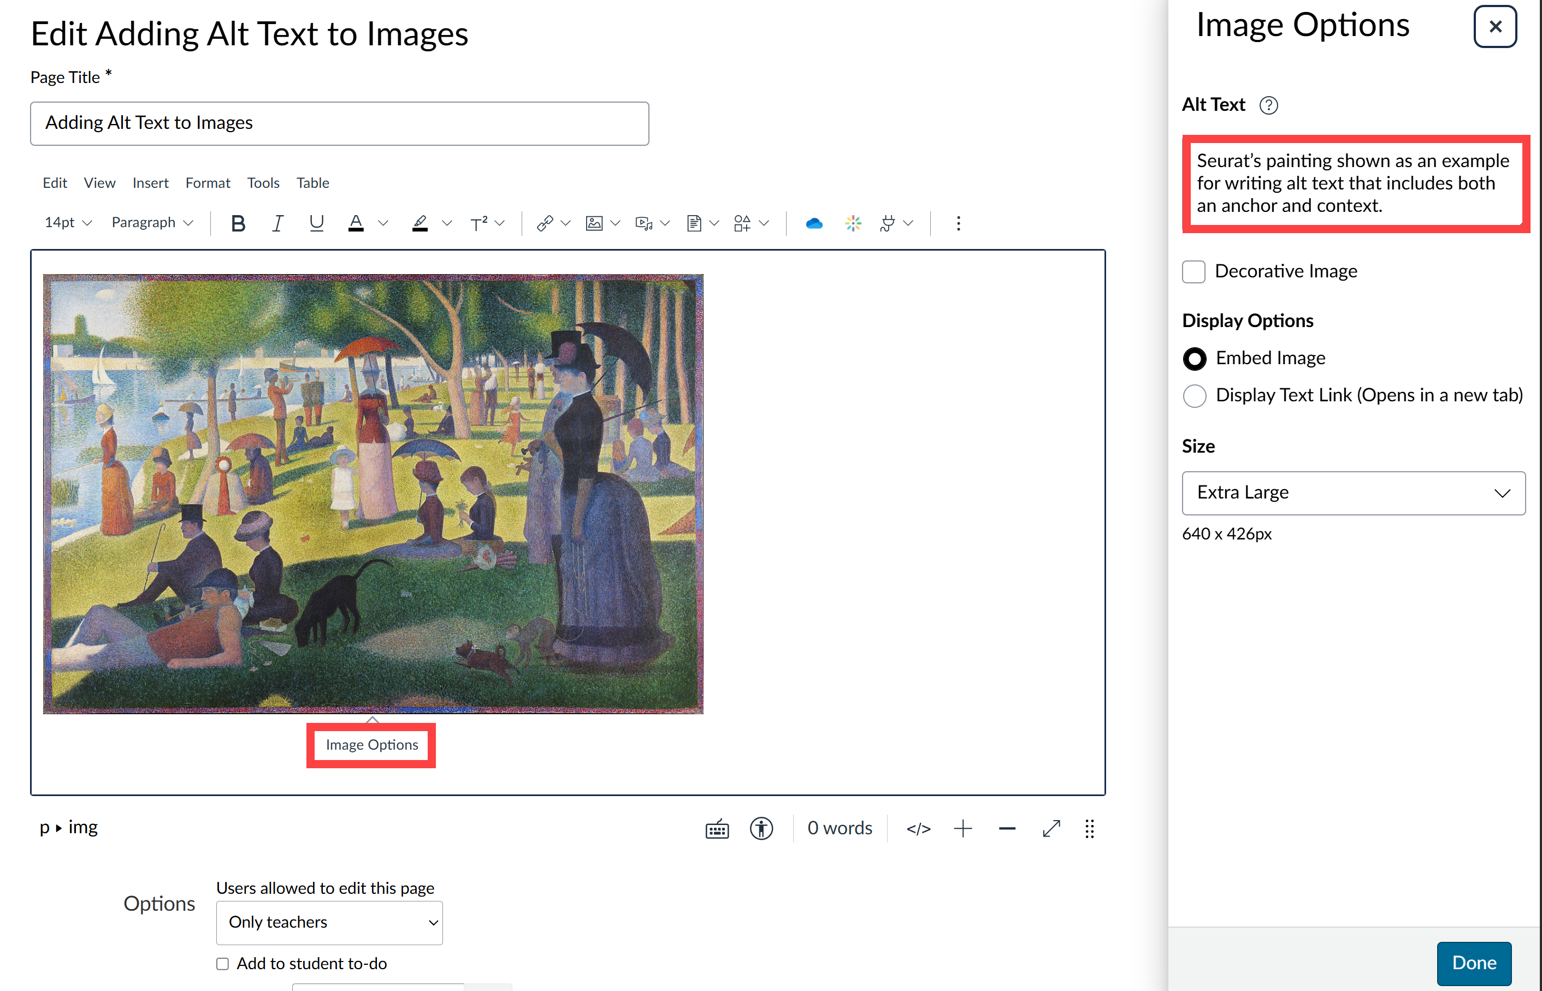
- Open the page, assignment, quiz, or other item where you added colored text
- Click Edit
- Click the image
- Select Image Options
- Enter text in the Alt Text field
- Check Decorative Image if appropriate
- Click Done

MS Word & Powerpoint:
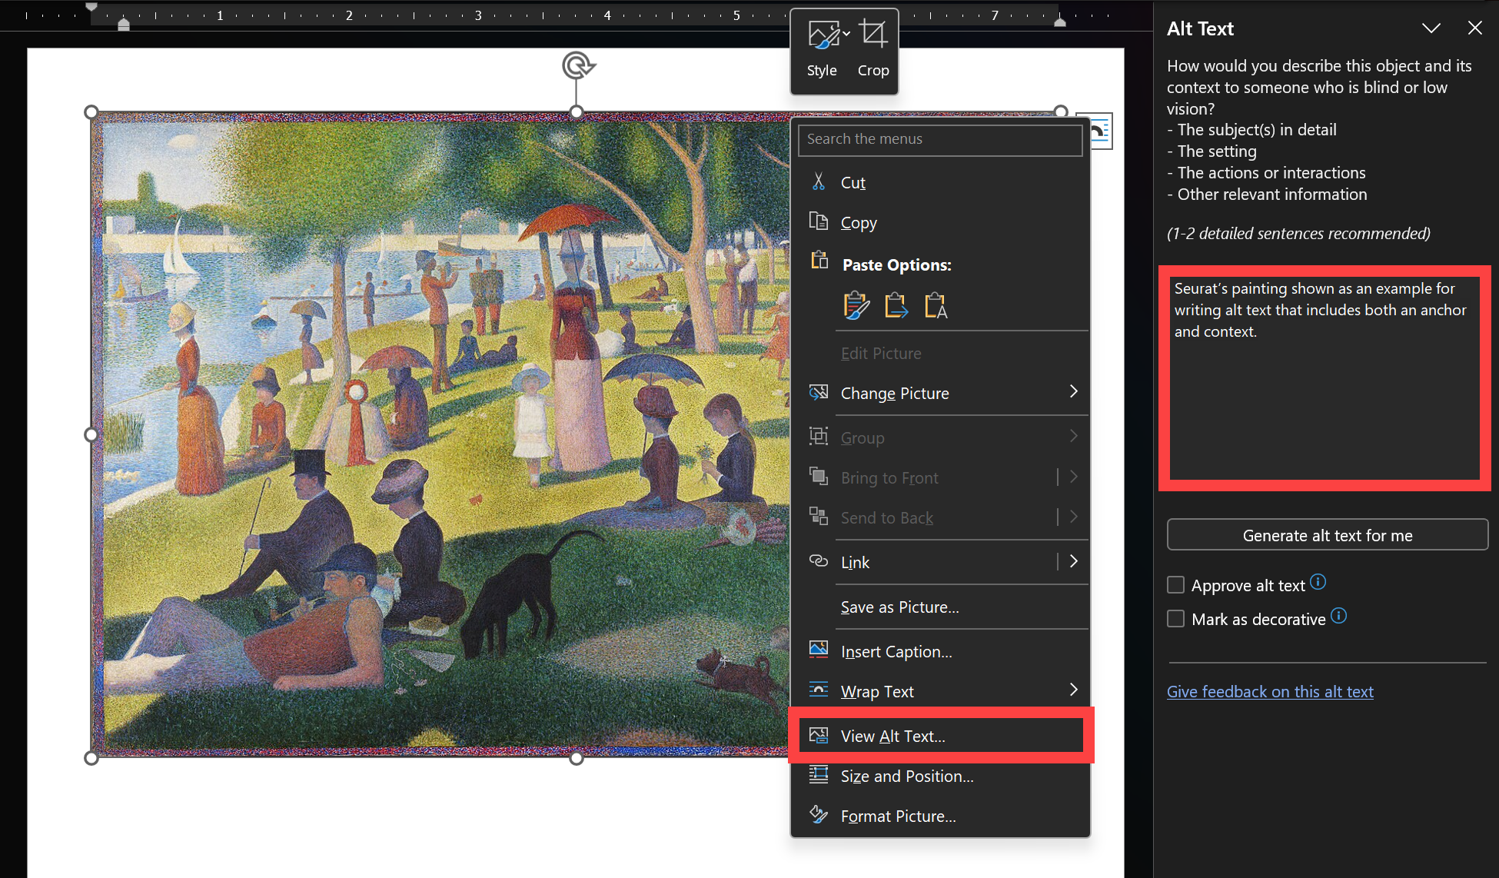
- Right-click the image
- Select Edit Alt Text
- Enter description in the panel
- Close the panel

Charts and Graphs

WCAG Reference
- 1.1.1 (A) Non-text Content
- 1.3.1 (A) Info and Relationships

What this means
Charts and graphs need alt text that communicates the key data and takeaway, not just what the chart looks like. Effective alt text identifies the chart type and summarizes the main insight.

What to do
- Add alt text to all charts and graphs
- Include a brief anchor (chart type and topic)
- Summarize the key trend, comparison, or takeaway
- Context summarizes what the data shows, focusing on the most important insight rather than every value
- Keep it concise (~120 characters or less in Canvas)
- Include relevant labels, values, or timeframes if important

What to avoid
- Describing visual details only (“blue bars with labels…”)
- Listing every data point
- Leaving out the main takeaway
- Repeating surrounding text without adding meaning

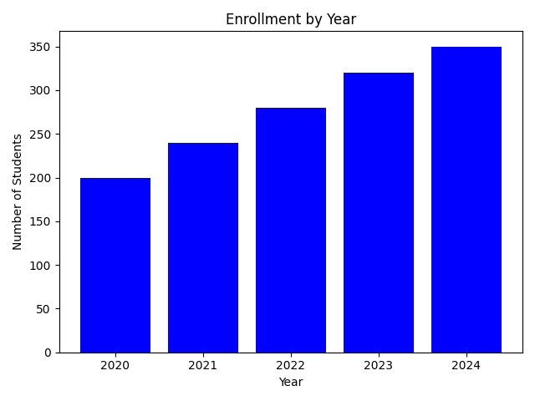

Examples
Good (anchor + context):
“Bar chart showing enrollment increased from 200 to 350 students between 2020 and 2024.”
Bad (visual only):
“Bar chart with blue bars labeled 2020 to 2024.”
→ Describes appearance but not meaning
Bad (data dump):
“Enrollment: 200 in 2020, 240 in 2021, 280 in 2022, 320 in 2023, 350 in 2024.”
→ Lists values but doesn’t summarize the trend

How to do it

Canvas:
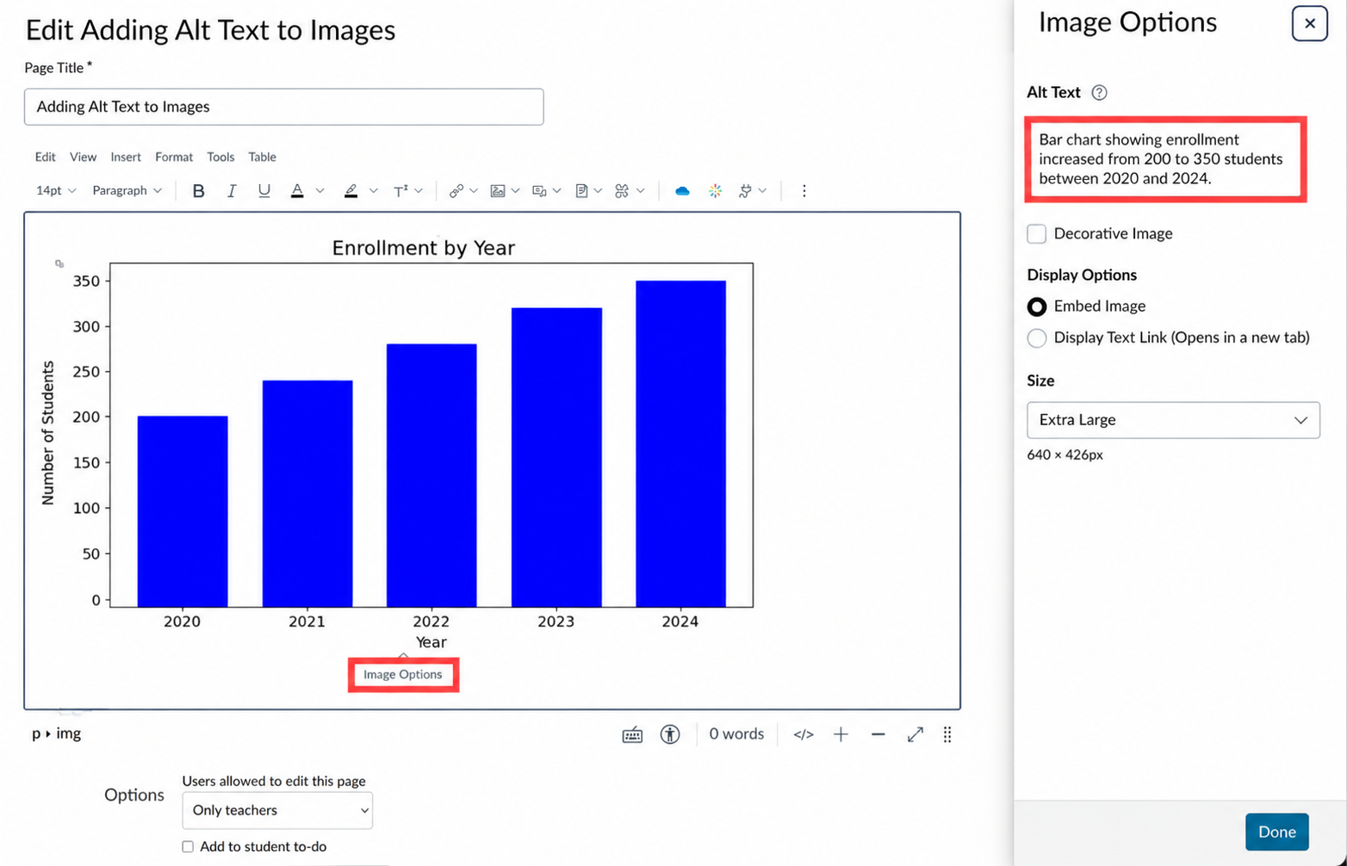
- Open the page, assignment, quiz, or other item where you added colored text
- Click Edit
- Click the image
- Select Image Options
- Enter text in the Alt Text field
- Check Decorative Image if appropriate
- Click Done

MS Word & Powerpoint:
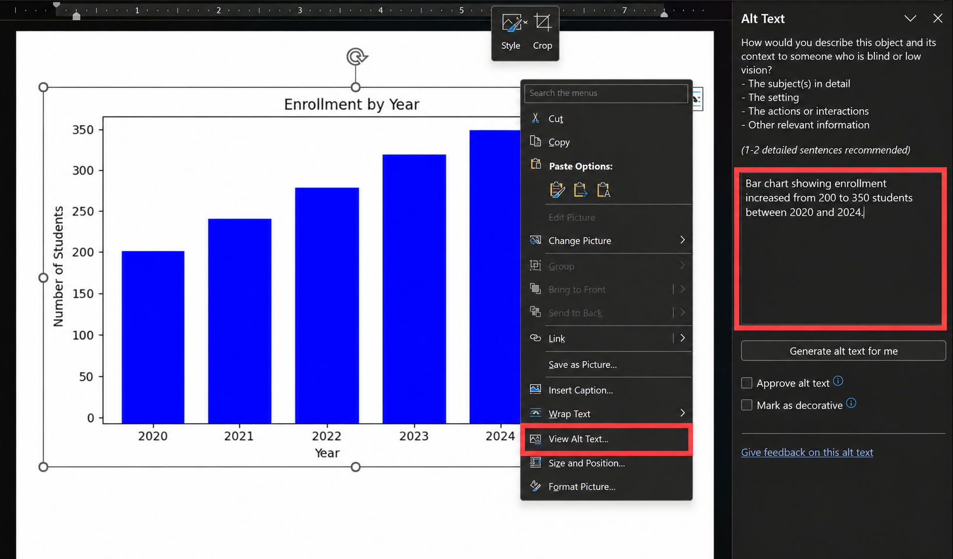
- Right-click the image
- Select Edit Alt Text
- Enter description in the panel
- Close the panel

Headings and Structure

WCAG Reference
- 1.3.1 (A) Info and Relationships
- 1.3.2 (A) Meaningful Sequence
- 2.4.6 (AA) Headings and Labels

What this means
- Headings and structure allow screen readers to understand how your content is organized.
- Sighted users scan pages visually for large, bold section titles. Screen reader users rely on actual heading structure to jump between sections, understand hierarchy, and navigate long content efficiently.
- If headings are not used correctly, the content may still look fine visually, but it loses its structure for assistive technology.
- Proper structure also makes content easier to scan for everyone — without it, long content becomes hard to use even when it looks visually organized.

Headings create an outline
Think of headings like a document outline or table of contents:
Heading 1 = main topic
Heading 2 = major sections
Heading 3 = subsections
Heading 4+ = deeper levels as needed
Each level should nest logically under the one before it.

Formatting vs. real structure
Here is the same course policy text, built three different ways. All three can look organized on screen — but only one of them actually is.
 | Document 1: Plain text | Document 2: Formatted (no styles) | Document 3: Properly structured
What it looks like | Course Policies  Attendance  Students must attend at least 80% of class sessions.  Grading  Grades are based on participation, exams, and assignments. | Course Policies  Attendance  Students must attend at least 80% of class sessions.  Grading  Grades are based on participation, exams, and assignments. | Heading 1 Course Policies  Heading 2 Attendance  Students must attend at least 80% of class sessions.  Heading 2 Grading  Grades are based on participation, exams, and assignments.
🔊 What a screen reader announces | “Course Policies. Attendance. Students must attend at least 80% of class sessions. Grading. Grades are based on participation, exams, and assignments.” | “Course Policies. Attendance. Students must attend at least 80% of class sessions. Grading. Grades are based on participation, exams, and assignments.”  (identical to Document 1 — bold and size changes are silent to a screen reader) | “Heading 1, Course Policies. Heading 2, Attendance. Students must attend at least 80% of class sessions. Heading 2, Grading. Grades are based on participation, exams, and assignments.”

Documents 1 and 2 sound identical to a screen reader, even though Document 2 looks organized on screen. Only Document 3’s headings are announced — because only Document 3 actually has them.

Beyond compliance
Headings aren’t just a requirement to check off. Screen reader users can pull up a list of every heading in a document and jump straight to the section they need — the same shortcut a sighted student gets from scanning bold subheadings, just accessed differently. Headings also save you time: update a heading style once and every instance updates, drag whole sections around in Word’s Navigation Pane, and get a table of contents for free.

What to do
- Apply heading styles ( Heading 2 , Heading 3 , etc.) instead of manually bolding or resizing text — bold and italics are for emphasis, not structure.
- Follow the outline logic and don’t skip levels (e.g., don’t jump from Heading 1 straight to Heading 3 ).
- In Canvas, the page or assignment title is already Heading 1 — start with Heading 2 in the editor, and never manually insert Heading 1 using HTML.
- In Word or PowerPoint, you can use the Title style for the document title, but it’s a good idea to use Heading 1 instead, since that’s what begins the structure. All structure is applied through the Styles panel.
- Write heading text that describes the content that follows — avoid vague headings like “Important” or “Note”.

Examples
Good example (clear hierarchy)
Heading 1 : Course Policies
Heading 2 : Attendance
Heading 2 : Grading
Heading 3 : Late Work
Heading 3 : Extra Credit
Why this works:
- Clear hierarchy
- No skipped levels
Each heading describes the content that follows
Bad example (skipped levels)
Heading 1 : Course Policies
Heading 3 : Attendance
Heading 2 : Grading
Problem:
- Heading 2 is skipped
- Structure becomes confusing for screen readers

What to avoid
- Skipping heading levels — e.g., going from Heading 1 straight to Heading 3 without a Heading 2 in between
- Making text bold or bigger to look like a heading, instead of applying an actual heading style — it may look right, but a screen reader won’t recognize it as one
- Applying a heading style just to make text stand out (e.g., marking a warning like “Important” as a Heading 2 to draw attention) — a heading should announce a new section, not flag emphasis
- Vague heading text like “Important” or “Note” that doesn’t describe what the section is actually about
- Writing long stretches of text with no headings at all, leaving nothing for a reader to scan or jump to

How to do it

Canvas:

- Highlight text
- Select Paragraph dropdown
- Choose Heading 2 or Heading 3

Word/PowerPoint:

- Highlight text
- Select Styles
- Choose appropriate Heading level

Use the Navigation Pane (Word)
In Word: View → Navigation Pane
This shows a live outline of your document while you write. Use it to jump between sections and catch skipped or incorrect heading levels — think of it as a built-in table of contents.

Lists

WCAG Reference
- 1.3.1 (A) Info and Relationships

What this means
- Lists convey structure — a set of related items, or steps that happen in a specific order. A real list tool embeds that structure in the document itself, not just in how it looks on screen.
- Screen readers announce real lists as lists — “list, 4 items,” or “item 2 of 5” — giving users a sense of scope and position that a block of plain text doesn’t provide.
- Typing a dash, asterisk, or number at the start of a line makes something look like a list, but a screen reader just reads that character as text. The items are announced as ordinary, disconnected sentences, with no indication they belong together or how many there are.
- Bulleted and numbered lists communicate different things: bullets group related items with no required order; numbers tell the reader that order matters.

What to do
- Use the actual list tool — Word’s List Bullet or List Number styles (Home tab → Styles), or the Bulleted List / Numbered List icons in Canvas — instead of typing dashes, asterisks, or numbers by hand.
- Use a bulleted list when items have no required order (resources, requirements, tips).
- Use a numbered list when order matters (steps in a process, a ranked sequence).
- Keep list items parallel in structure and focused on one idea each.
- Watch for Word’s List Paragraph trap: content pasted from a webpage, PDF, or another document often lands already styled List Paragraph with a hanging indent and what looks like a bullet or number. The style name alone doesn’t mean it’s a real list — check that the Bullets or Numbering button on the Home tab is actually highlighted before trusting it, and reapply real list formatting if it isn’t.

Examples
Here is the same set of items, built two different ways. Both can look identical on screen — but only one is announced as a list.
 | Typed list (dashes typed manually) | Real list (list tool used)
What it looks like | - Book  - Pen  - Paper | - Book  - Pen  - Paper
🔊 What a screen reader announces | “Book. Pen. Paper.”  (three separate, unrelated sentences — no indication these are a list) | “List, 3 items. Book. Pen. Paper. Out of list.”
The typed list and the real list can look identical on the page — but only the real list is announced as a list, with a count and boundaries a screen reader user can navigate by.

Bad example (typed numbered list)
1. Export the file
2. Upload to Canvas
3. Add captions
Why this fails:
- A screen reader reads “1. Export the file” as literal text, then “2. Upload to Canvas” as a separate, unrelated line — it never announces “item 1 of 3” or “item 2 of 3.”
- If a step is added, removed, or reordered, every number has to be retyped by hand.

What to avoid
- Typing dashes, asterisks, or numbers instead of using the list tool
- Using indentation alone to make something look like a list
- Trusting the List Paragraph style name as proof of a real list, without checking whether list formatting is actually applied
- Mixing bulleted and numbered formatting inconsistently within the same list
- Turning a normal paragraph into single-word bullets just for visual effect, when it isn’t actually a list of items

How to do it

Canvas:
- Highlight the text
- Select the Bulleted List or Numbered List icon in the toolbar
- Press Enter to start a new item; use Shift+Enter for a line break within the same item

Word/PowerPoint:
- Highlight the text
- On the Home tab, select Bullets or Numbering
- If pasting from another source, reselect the text afterward and reapply Bullets or Numbering to make sure it’s a real list, not just indented text

Links

WCAG Reference
- 2.4.4 (A) Link Purpose (In Context)
- 3.3.2 (A) Labels or Instructions

What this means
Links must clearly describe where they go so users can understand their purpose without needing surrounding context.
Screen reader users often:
- Navigate from link to link
- View a list of all links on a page
If link text is vague or repetitive, the content becomes difficult to navigate.
For example: a sighted user reading “For more information, click here” can tell what it leads to from the sentence around it. A screen reader user browsing by links may hear only:
link click here
link click here
link click here
— with no way to tell the three links apart.
Clear, descriptive link text improves navigation for everyone — not just screen reader users.

What to do
- Use descriptive link text that identifies the destination
- Keep link text concise but meaningful
- Place the most important words at the beginning
- Indicate file type when linking to documents (PDF, Word, etc.)
- Indicate if a link opens in a new window or tab
- Use underlined links whenever possible

Link appearance and color
Links must be visually distinguishable from surrounding text.
Keep links underlined — it’s the most reliable, accessible way to make them recognizable without relying on color alone.
If you don’t underline a link, both of the following must be true instead:
- Text must have 4.5:1 contrast against the background, AND
- Link text must have at least 3:1 contrast against surrounding text
This applies to every link state — default, hover, visited, and focus/active — not just how the link looks normally.
If these conditions are not met, links may not be distinguishable for many users.

Providing both a link and a URL
Some materials — like a syllabus that’s also printed as a handout — get used both online and in print. In these cases, provide both: a descriptive link for digital readers, and the full URL underneath for anyone reading on paper.
Course materials are available in the Course Resources folder
https://canvas.ucsd.edu/courses/12345

Examples
 | Bad example | Good example
Vague link text | For more information, click here | Read the Canvas accessibility guidelines
Repeated link text | Click here for syllabus  Click here for assignments  Click here for grading | View the Course Syllabus  Review Assignment Instructions  Check the Grading Policy
Raw URL in running text | https://www.example.com/resources/accessibility-guide.pdf | Download the Accessibility Guide (PDF)

What to avoid
- “Click here,” “Read more,” or vague link text
- Repeating identical link text for different destinations
- Using raw URLs when descriptive links are possible
- Removing underlines without meeting contrast requirements
- Using color alone to indicate links
- Writing overly long or unclear link text
- Adding “link to” or “click” in link text
- Links that do not go anywhere

How to do it

Creating external links
- Highlight the text you want to link
- Select the Link icon
- Choose External Links
- Enter descriptive link text and URL
- Select Done
Canvas will recognize most URLs even without typing “https://”.
To edit a link later, click it and select Link Options — you can change the link text or update the destination.

Linking to course content (recommended)
- Place your cursor where you want the link
- Select the Link icon
- Choose Course Links
- Select:
  - Pages
  - Assignments
  - Quizzes
  - Discussions
  - Announcements
  - Modules
- Choose the item
Canvas inserts the link automatically.
Benefits:
• No need to copy URLs
• Reduces broken links
• Keeps links consistent

Linking images
- Insert an image
- Click the image
- Select Link Options
- Add a destination URL
Important:
• Always include alt text for images
• Alt text should describe the image, not just the link

Linking to files
- Use Documents or Course Files
- Select your file
After inserting:
- Click the link
- Select Link Options
Display options may include:
- Disable preview
- Preview in overlay
- Embedded preview
Best practice:
- Include file type in link text
- Example: Download Syllabus (PDF)

Important limitation: Canvas Inbox (and similar plain-text tools)
The Canvas Inbox uses a plain text editor.
You cannot create descriptive hyperlinks.
This applies to other plain-text tools too — for example, some ticketing systems.
Best practices:
- Use full URLs
- Place links on their own line
- Provide clear context around the link

Color and Contrast

WCAG Reference
- 1.4.1 (A) Use of Color
- 1.4.3 (AA) Contrast (Minimum)
- 1.4.11 (AA) Non-text Contrast

What this means
Text must be readable against its background, and color cannot be the only way information is communicated.
Accessibility standards measure this using color contrast ratios, which compare text color to its background.
- Normal text must meet at least 4.5:1 contrast
- Large text must meet at least 3:1 contrast

What to do
- Use dark text on a light background (or vice versa)
- Ensure all text meets minimum contrast requirements (4.5:1)
- Use additional indicators besides color (icons, labels, bold text)
- Prefer darker colors from the Canvas palette
- Pair readable colors with clear, screen-friendly fonts

Canvas color palette guidance
Canvas includes preset colors, but not all meet accessibility standards.
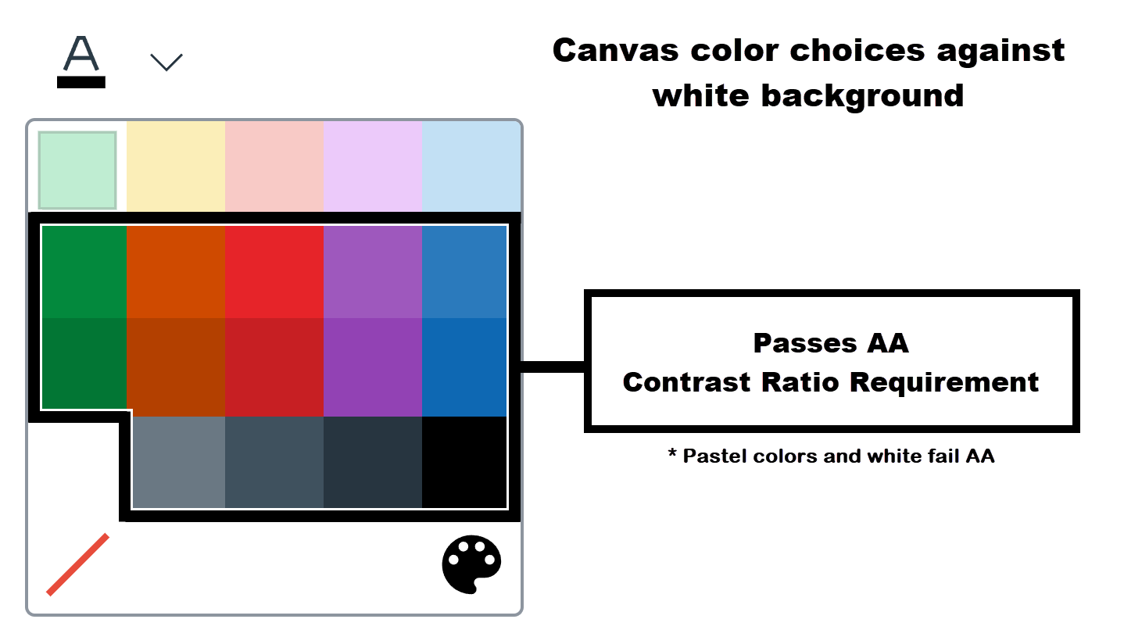
- The five pale pastel colors, light green, light orange, light red, light purple, and light blue, fail against a white background.
- White text also fails on a white background.
- The colors in the second row, green, orange, red, purple, and blue just clear AA for normal text.
- The colors in the third row, dark green, dark orange, dark red, dark purple, and dark blue are more comfortably above AA for normal text.
- Light gray, gray, dark gray, and black in the fourth row meet AA for normal text.

Microsoft color palette guidance
The default font color palette in Microsoft Word includes colors that do not meet WCAG AA contrast requirements for text on a white background.
However, enabling the “High-contrast only” toggle limits the palette to colors that meet the minimum 4.5:1 contrast ratio for normal text on a white background.
When using other page background colors, the palette adjusts automatically, but contrast should be verified using a contrast checker.
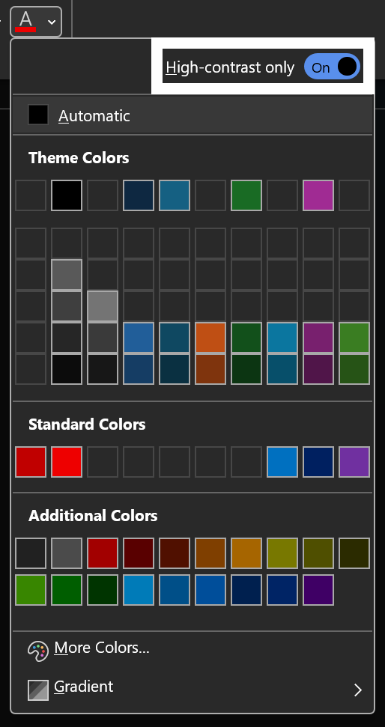

Color contrast vs. legibility
These are not the same:
- Color contrast = difference between text and background (measured and required)
- Legibility = how easy the font is to read (style, spacing, thickness)
A clearer font can improve readability, but it does not fix poor contrast.
Both need to be addressed.
Non-text contrast
Contrast requirements don’t just apply to text. Important visual elements also need to be easy to see. In general, anything students need to recognize or interact with should have at least 3:1 contrast against adjacent colors.
In practice, this most often applies to:
- Buttons, form fields, and icons
- Elements like buttons, checkboxes, and icons should stand out clearly from their background.
- Charts, diagrams, and instructional graphics
- Key parts of a visual, like bars in a chart or lines in a diagram, need to be distinguishable from each other and the background.
One key difference from text contrast is that non-text elements may need contrast in more than one place. For example, an icon must contrast with both its background and any shapes inside it.

What you don’t usually need to worry about
- Photos, logos, and realistic images
- Specialized visuals where lower contrast is necessary to preserve meaning (eg, heatmaps)
If you’re creating custom visuals or styled elements, that’s when this guideline becomes more relevant.

What to avoid
- Light pastel text on a white background
- White text on light backgrounds
- Using color alone to indicate meaning (e.g., “items in red are required”)
- Assuming a font change will fix contrast issues

How to do it

Check contrast before publishing
- Go to the WebAIM Contrast Checker
- https://webaim.org/resources/contrastchecker/
- Enter:
  - Text color
  - Background color
- Review the result:
  - Must pass 4.5:1 contrast for normal text

In Word / PowerPoint
- Select your text
- Open Font Color in the Home tab
- Choose a darker or higher contrast color
- Recheck using WebAIM

In Canvas
- Highlight text
- Use the Text Color tool
- Avoid light or pastel colors
- Verify contrast using WebAIM

Tables

WCAG Reference
- • 1.3.1 (A) Info and Relationships
- • 1.3.2 (A) Meaningful Sequence

What this means
Tables should only be used to present data, and they must be structured so screen readers can understand how information is related.
When tables are set up correctly, screen readers can:
- Identify rows and columns
- Read header information
- Help users navigate the table
If tables are not structured properly, the content may be read in a confusing or meaningless order.

What to do
- Use tables only for data, not for layout
- Include clear column headers and/or row headers
- Keep tables simple and easy to follow
- Ensure the reading order makes sense from left to right, top to bottom
- Include a caption or brief description that explains what the table shows

What to avoid
- Using tables for page layout or visual formatting
- Missing or unclear headers
- Complex tables with merged or split cells
- Empty cells that create confusion
- Tables without captions or context
- Tables that rely on visual layout instead of logical structure
- Large, dense tables without explanation
- Content that does not make sense when read in order

Examples
Bad example (no headers)
Name | Age | Birthday
Jackie | 5 | April 5
Beth | 8 | January 14
Problem:
- No header structure identified
- Screen reader cannot associate data correctly

Good example (with headers)
Name | Age | Birthday
Jackie | 5 | April 5
Beth | 8 | January 14
(With proper header formatting applied)
Why this works:
- Headers define each column
- Data relationships are clear

Bad example (used for layout)
A table used to position text or images on a page
Problem:
- No meaningful data relationships
- Can create confusing reading order

Bad example (complex structure)
Table with merged cells, nested tables, or irregular layout
Problem:
- Difficult to navigate
- Screen readers may misinterpret structure

Table captions (Canvas requirement)
Canvas will flag tables that do not include a caption in the Accessibility Checker.
While captions are not always strictly required by WCAG, they are strongly recommended and may be required by accessibility tools.
Best practice:
- Add a short description above the table
- Clearly explain what the table contains
Example:
Table: Weekly Office Hours Schedule

How to do it – Set Caption

Canvas
- Insert a table using the table tool
- Add a header row (and/or column if needed)
- Enter data clearly and consistently
- Add a caption or short description above the table
- Keep the structure simple
Tip:
Avoid merging cells unless absolutely necessary.

Word / PowerPoint
- Insert a table
- Use Table Design → Header Row
- Add clear column headings
- Add a caption or brief description above the table
- Keep layout simple and consistent

How to do it – Set Header Row

Word
- Click inside the table
- Go to Table Design
- Check Header Row
- Make sure the first row contains labels

PowerPoint
- Select the table
- Go to Table Design
- Check Header Row
- Ensure top row contains column labels

Canvas
- Insert table using the editor
- Click inside the table
- Open Table Properties (or options menu)
- Set:
- Header row = first row

Video and Captions

WCAG Reference
- 1.2.2 (A) Captions (Prerecorded)
- 1.2.1 (A) Audio-only and Video-only (Prerecorded)
- 1.2.3 (A) Audio Description or Media Alternative (Prerecorded)
- 1.2.5 (AA) Audio Description (Prerecorded) (include if you want to be complete, even if rarely enforced at instructor level)

What this means
Videos must be accessible through captions and transcripts.

What to do
- Provide accurate captions
- Provide transcripts when needed

What to avoid
- Unedited auto captions
- No captions

How to do it

Zoom recordings (recommended)

If using “Record to Cloud”:
- Captions are automatically generated
- Video transfers to Kaltura / My Media
- Go to My Media (Kaltura)
- Open the video
- Review captions
- Edit errors

If recording to your computer
- Upload the video to My Media (Kaltura)
- Wait for captions to generate
- Review and edit captions

Editing captions (VTT files)
If you download captions:

Windows
- Open with Notepad

Mac
- Open with TextEdit

Steps
- Open the .SRT file
- Edit text only
- Do NOT change timestamps
- Save file

Re-upload captions (if needed)
- Go to video in My Media
- Open Captions
- Upload corrected SRT file

Notes
- Auto captions are not accurate enough by default
- Zoom deletes cloud recordings after ~30 days, so check My Media in Canvas for a copy of the recording
If captions are not reviewed, the video is not compliant

